+
National Rally – Jurien Bay –
October 13th to 19th 2022

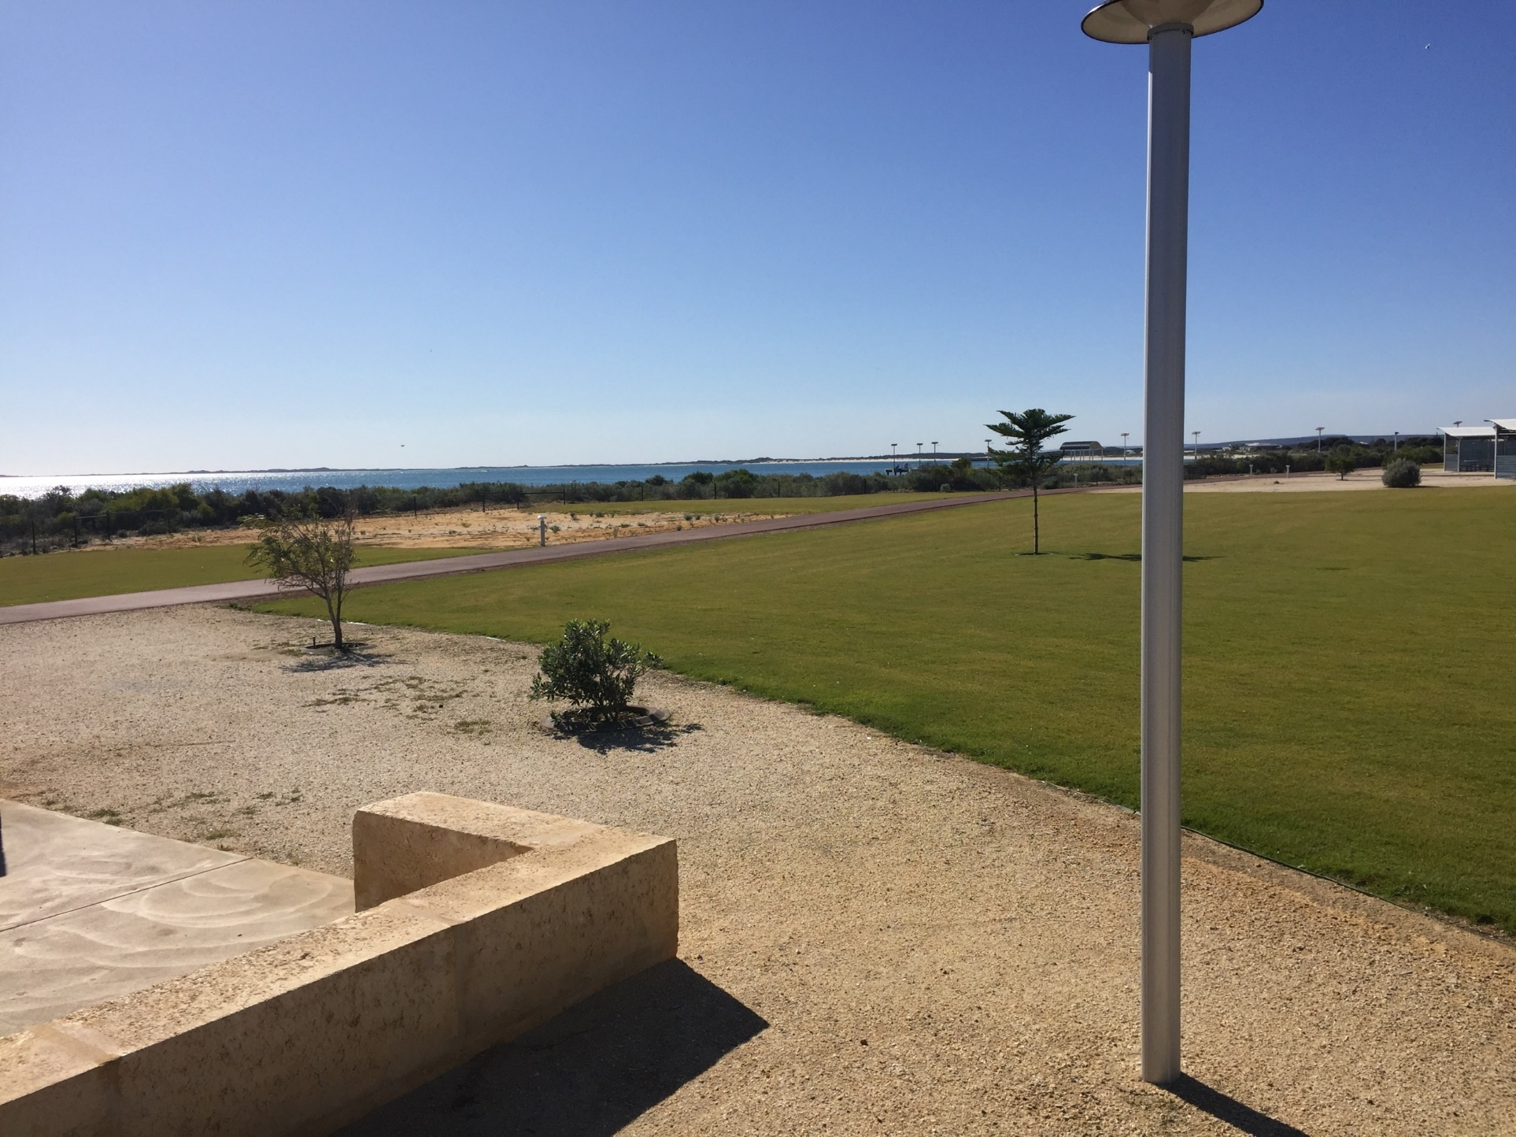

Day Time Event
Day 1 - Thursday October 13
2.00pm Check in at Recreation Centre

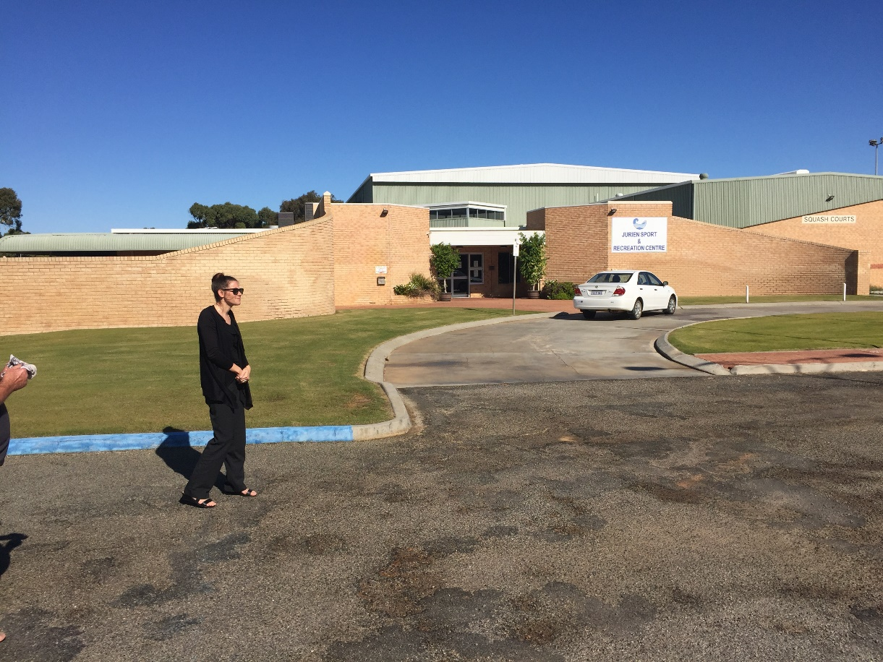

Town Drive (at your own leisure)

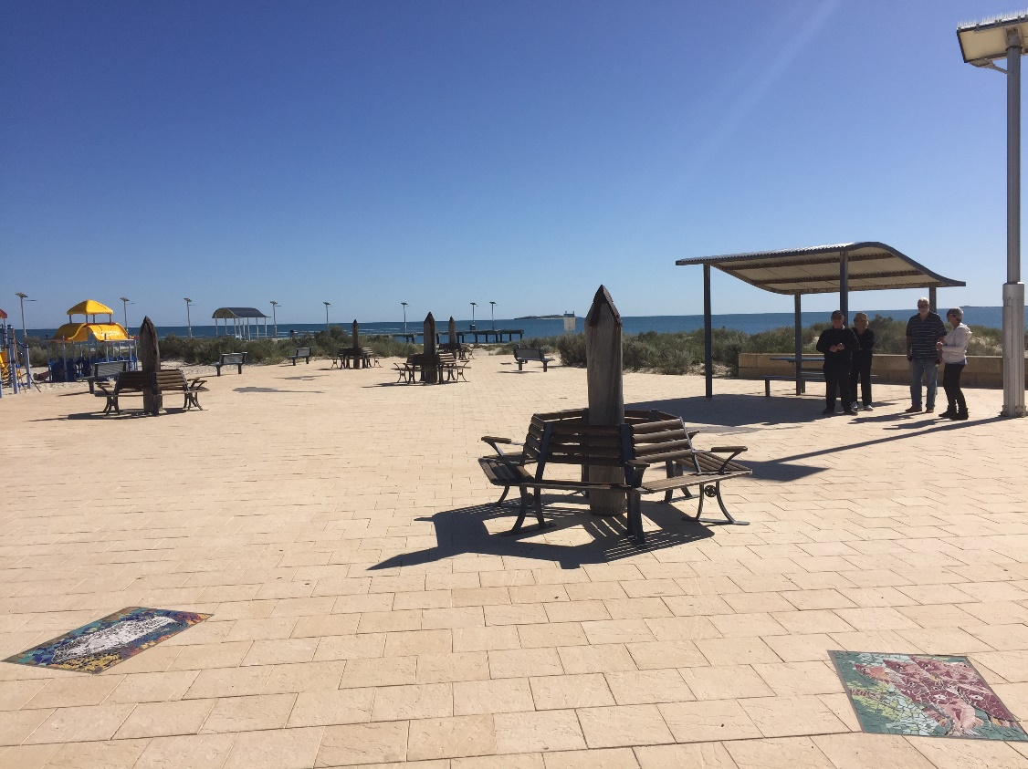
evening Pre-Dinner Drinks (BYO)

Welcome Barbecue (Jurien Bay Men’s Shed at Motel Lawn Area)

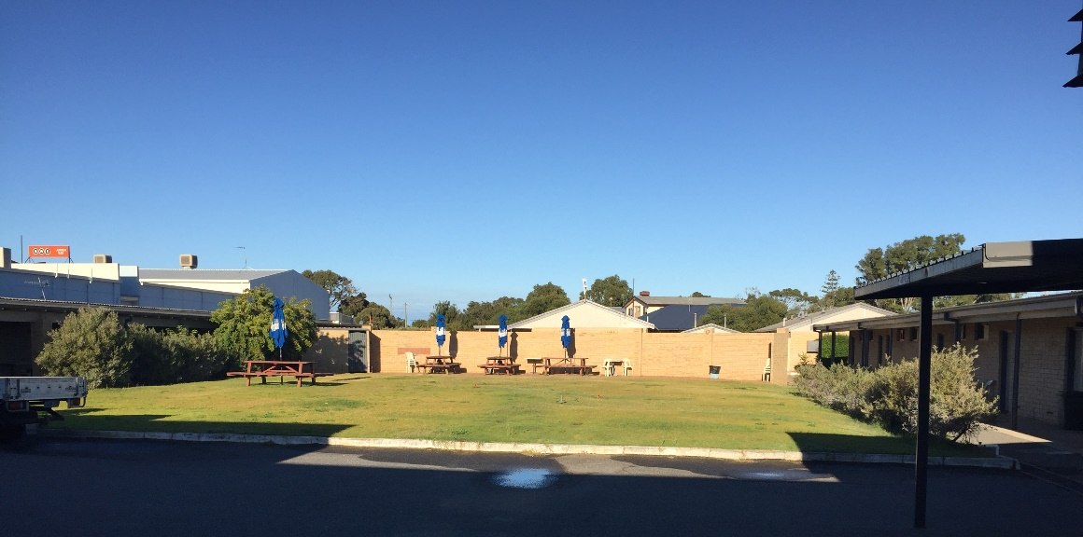

Day 2 - Friday October 14
am Sandy Cape (Sandboarding, Swimming, Snorkelling)

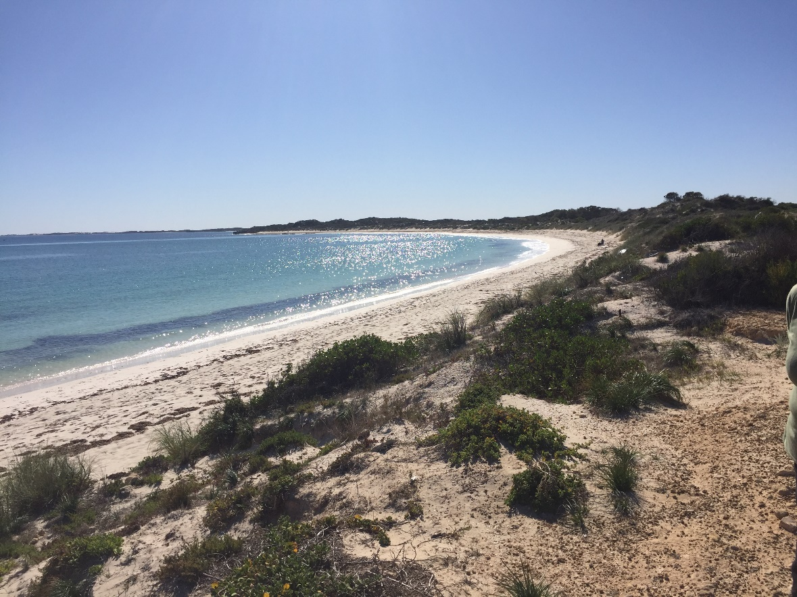

pm Salad Rolls Lunch (CWA or similar)
Mt Leseuer National Park. (18.5km Sealed Loop drive) 1,100 species of Wildflowers.
OR
Continue to Green Head and Dynamite Bay and thgen Mt Leseuer.
Pre AGM
evening Dinner at Recreation Centre
Pig Races / Demolition Derby

Day 3 - Saturday October 15
am/pm Display Day at Fauntleroy Park

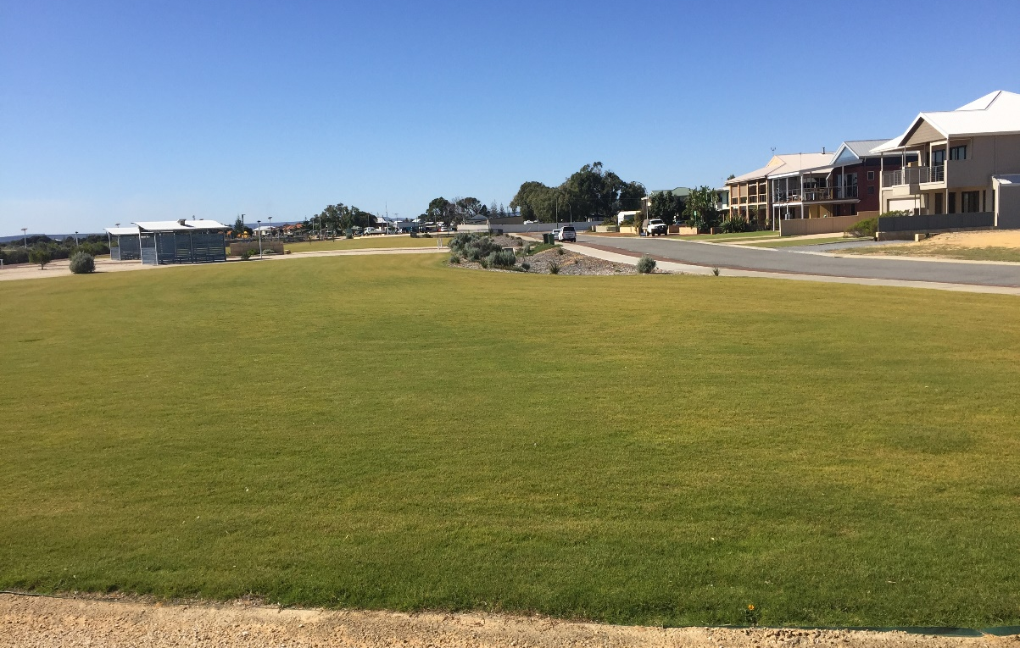

evening Dinner Dance at Recreation Centre. (Shuttle Buses Available)
Music by Dave McSweeney – Keyboard, Guitar, Vocals.

Day 4 - Sunday October 16
am Spares, Regalia, Library
pm Vincent Motorbike Museum

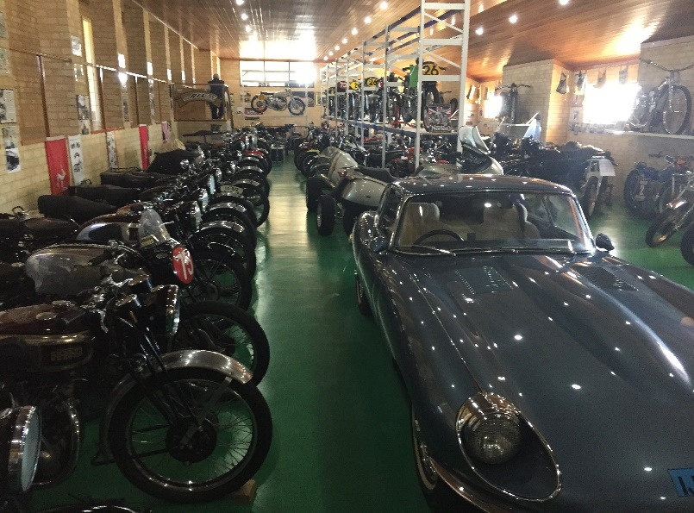
evening Dinner (Own Arrangements)
Patsy Cline Tribute Show at Rec Centre (8 PM). Public invited to attend.

Day 5 - Monday October 17

am Wedge Island.
Lake Thetis. Boardwalk to view Thrombolites.
pm Lunch at Cervantes
Nambung National Park
evening Pub Dinner followed by AGM

Day 6 - Tuesday October 18

Tuesday am/pm Activity Day (Sea Lion Tour, Fishing Charter, Sky Diving)
am/pm Optional 4WD bus to Stockyard Gully Caves

evening Catered Dinner at Sandpiper Tavern (optional)
Post AGM/ Free Time for Socialising

Day 7 - Wednesday October 19

Wednesday am Farewell Breakfast (Hotel)
Depart for Home

Further Photos
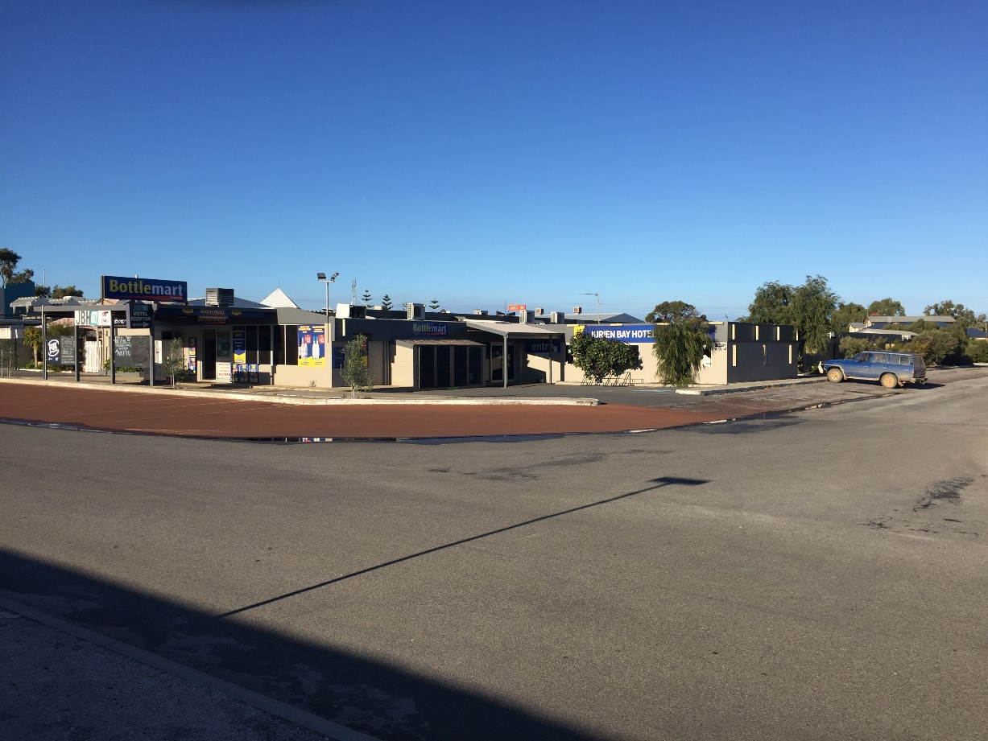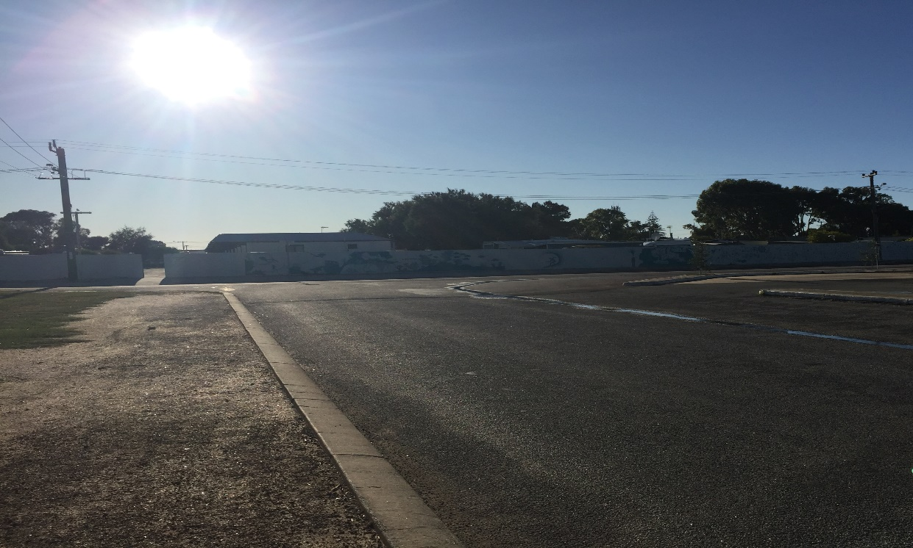
Hotel/Motel Caravan Park from Motel
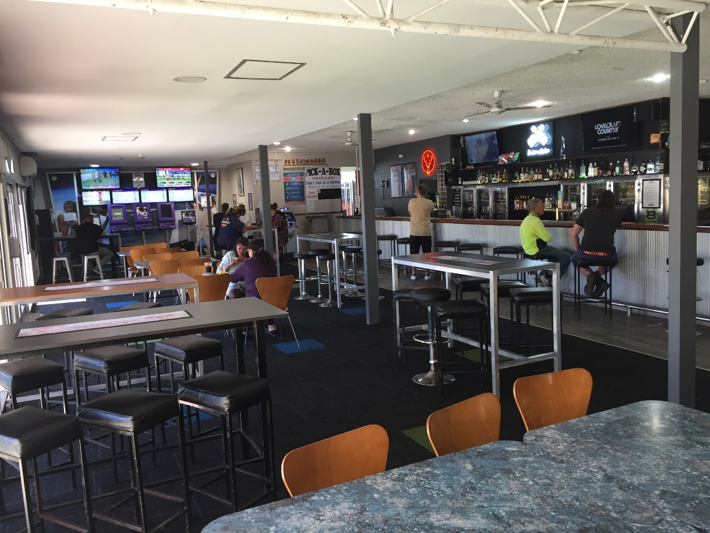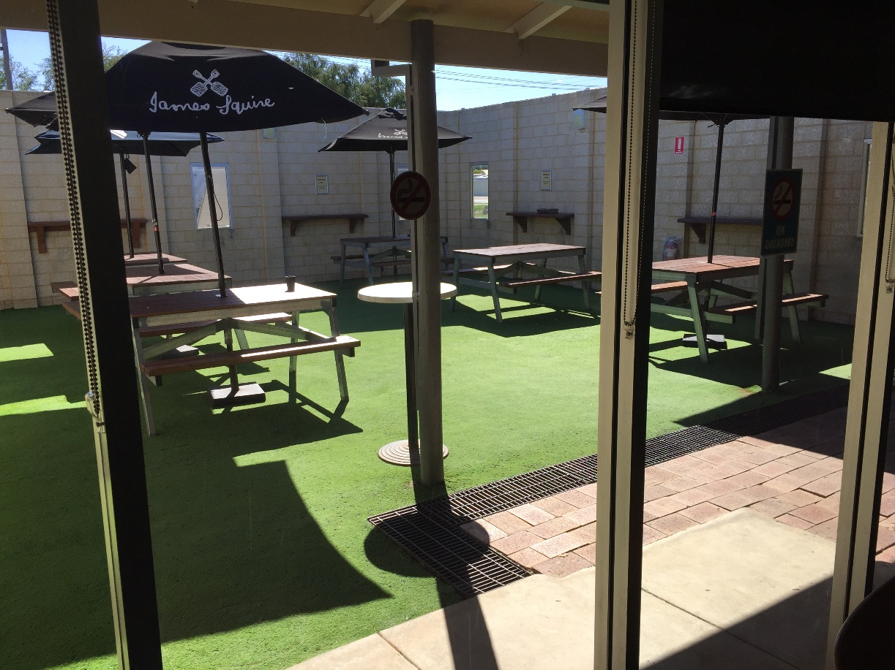
Hotel Front Bar & Lounge Beer Garden
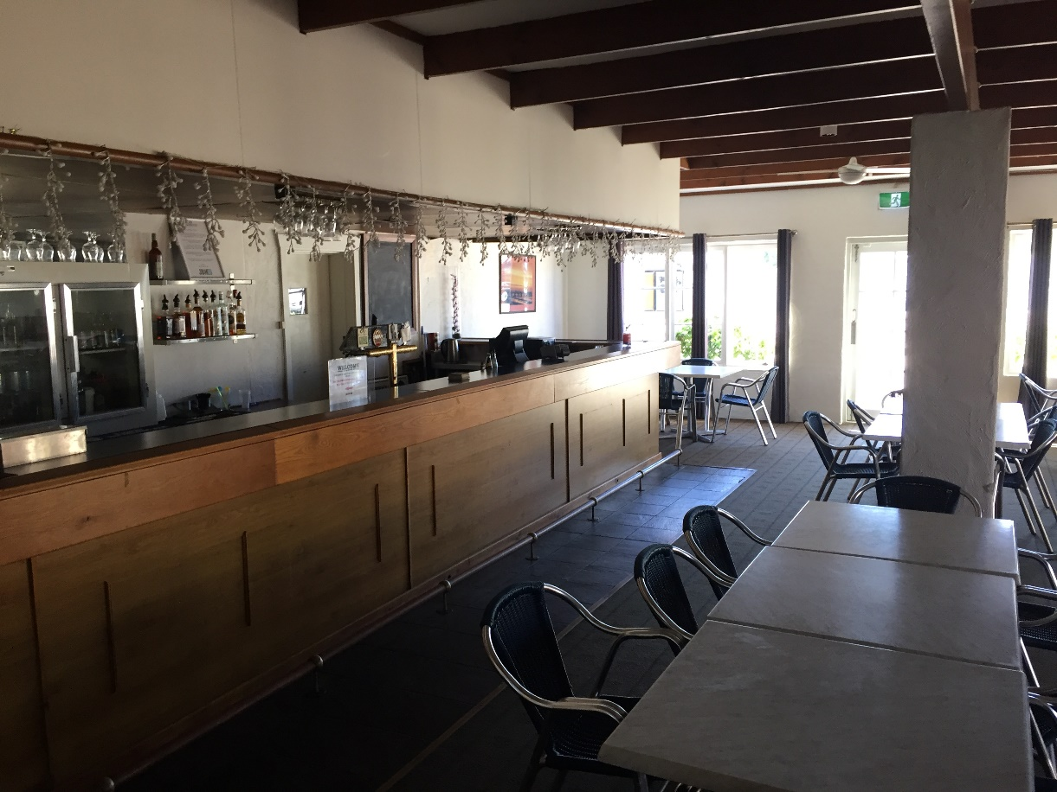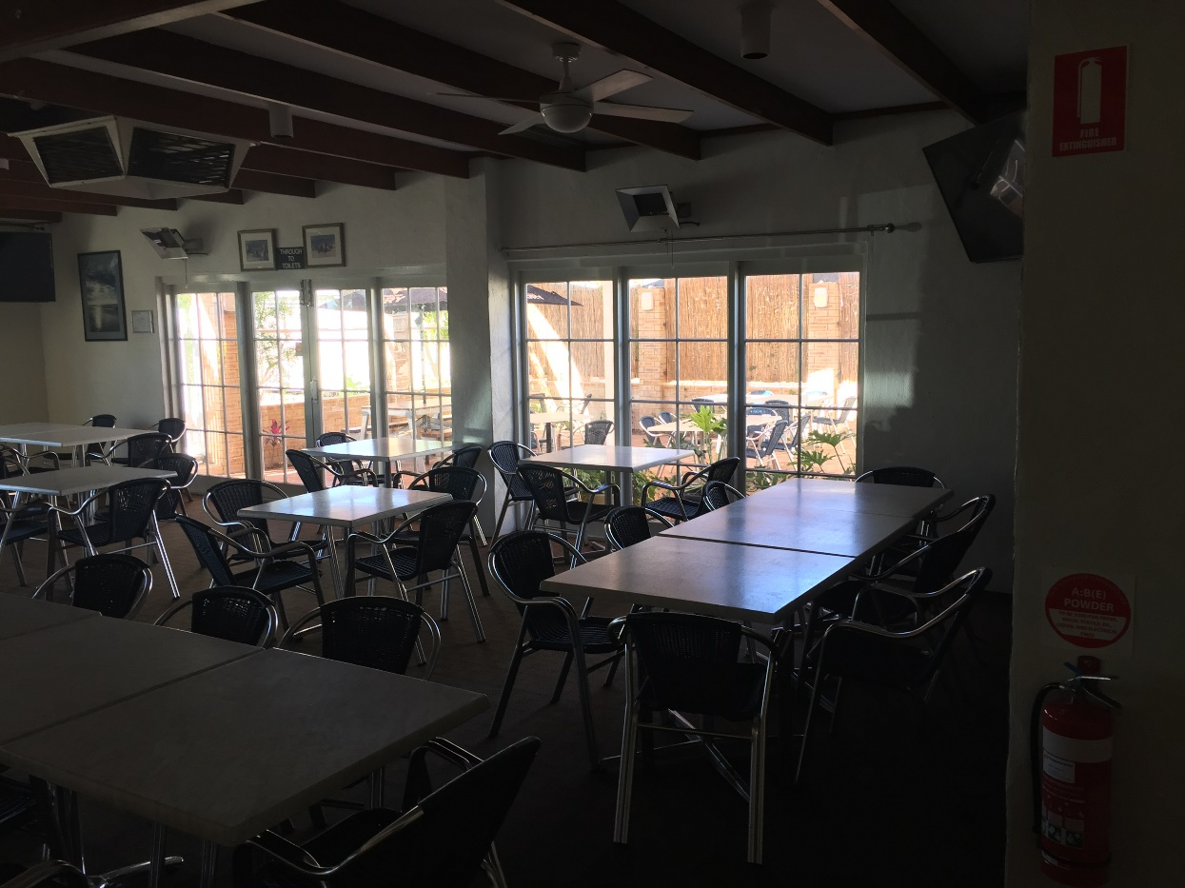
Dining Room Bar Dining Room
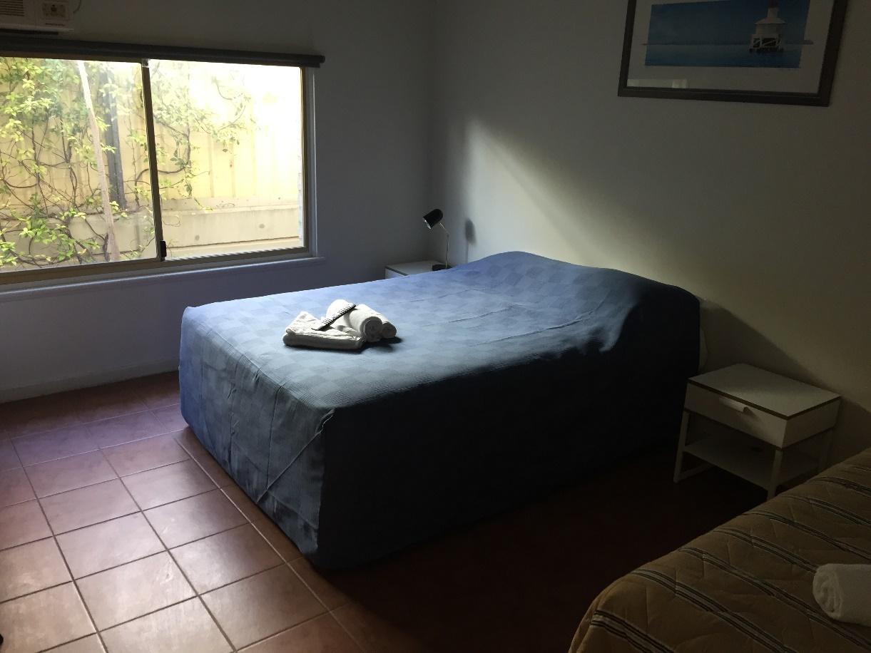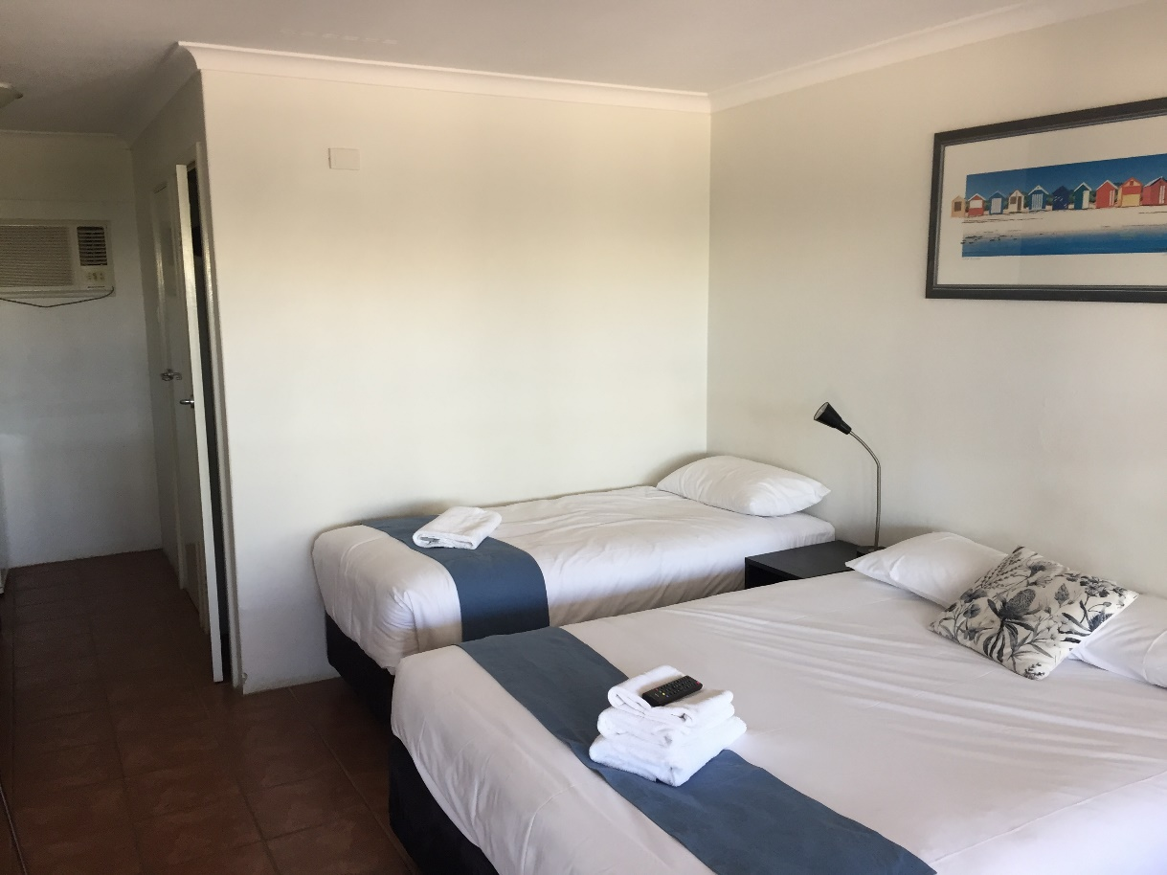
Motel Room – Queen plus Single Motel Room – Double plus Single
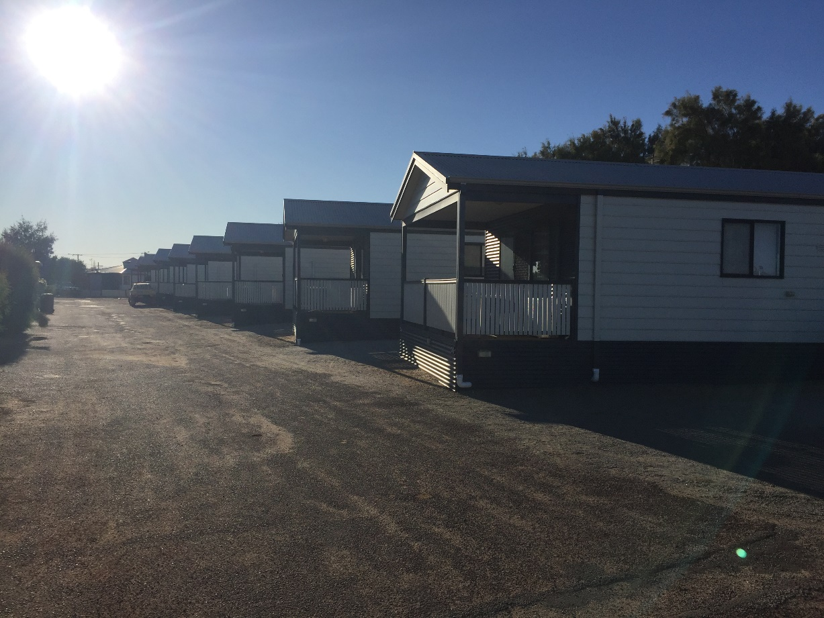
Caravan Park Units

