VAUXHALL OWNERS CLUB of AUSTRALIA
THE 2026
VICTORIAN NATIONAL RALLY
TO BE HELD FROM 11 MARCH TO 18 MARCH
THE RALLY IS TO BE HELD IN THE CENTRAL
GOLDFIELDS OF VICTORIA AT MARYBOROUGH
THE RALLY HEAD QUARTERS WILL BE AT THE:
GOLDEN COUNTRY MOTEL/CARAVAN PARK MARYBOROUGH 03 5461 1101

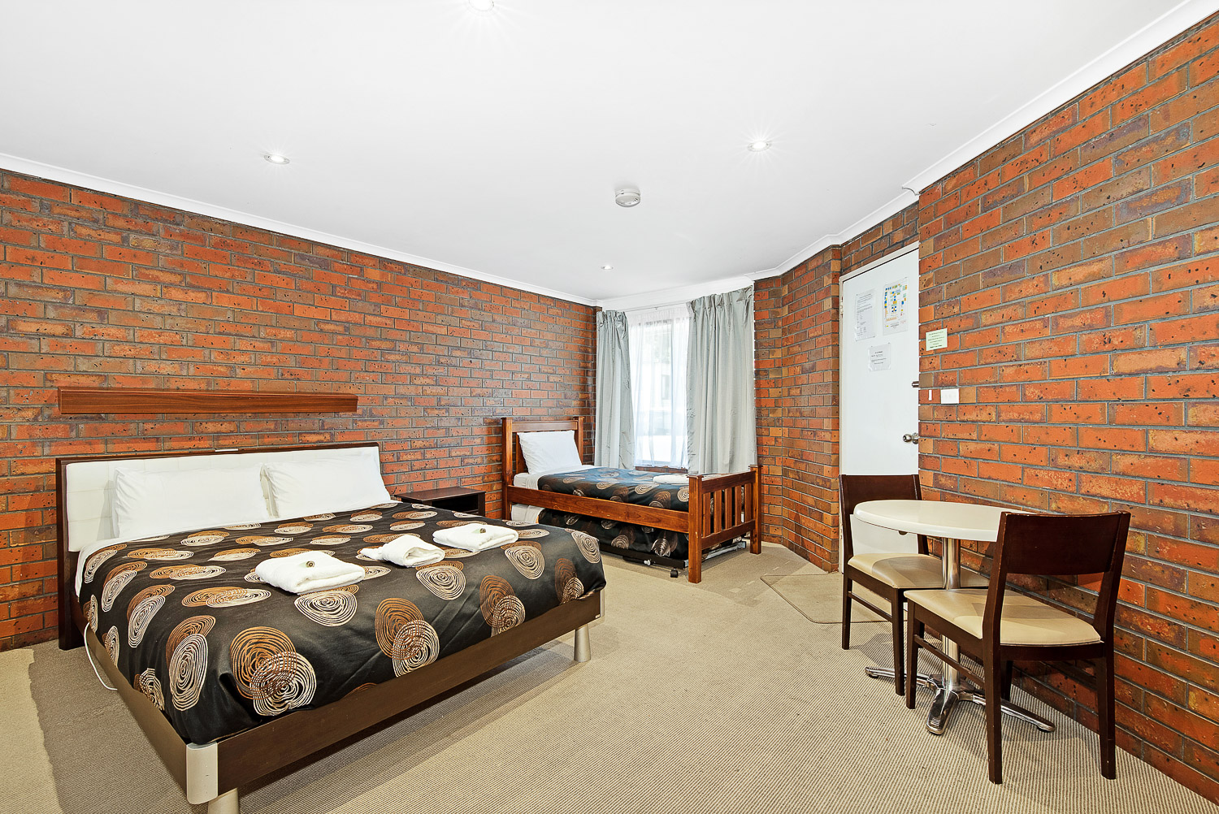
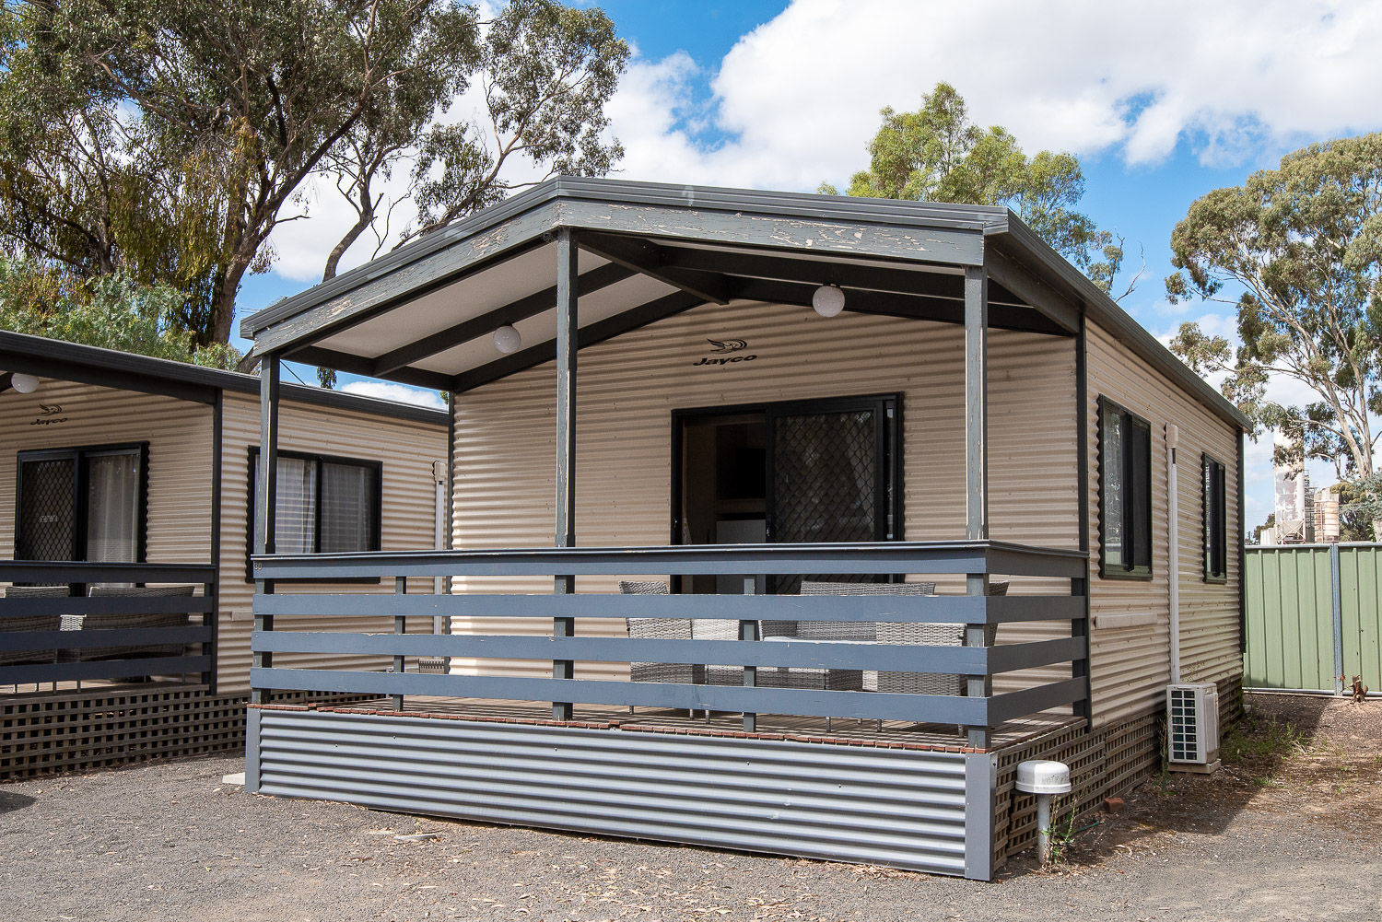

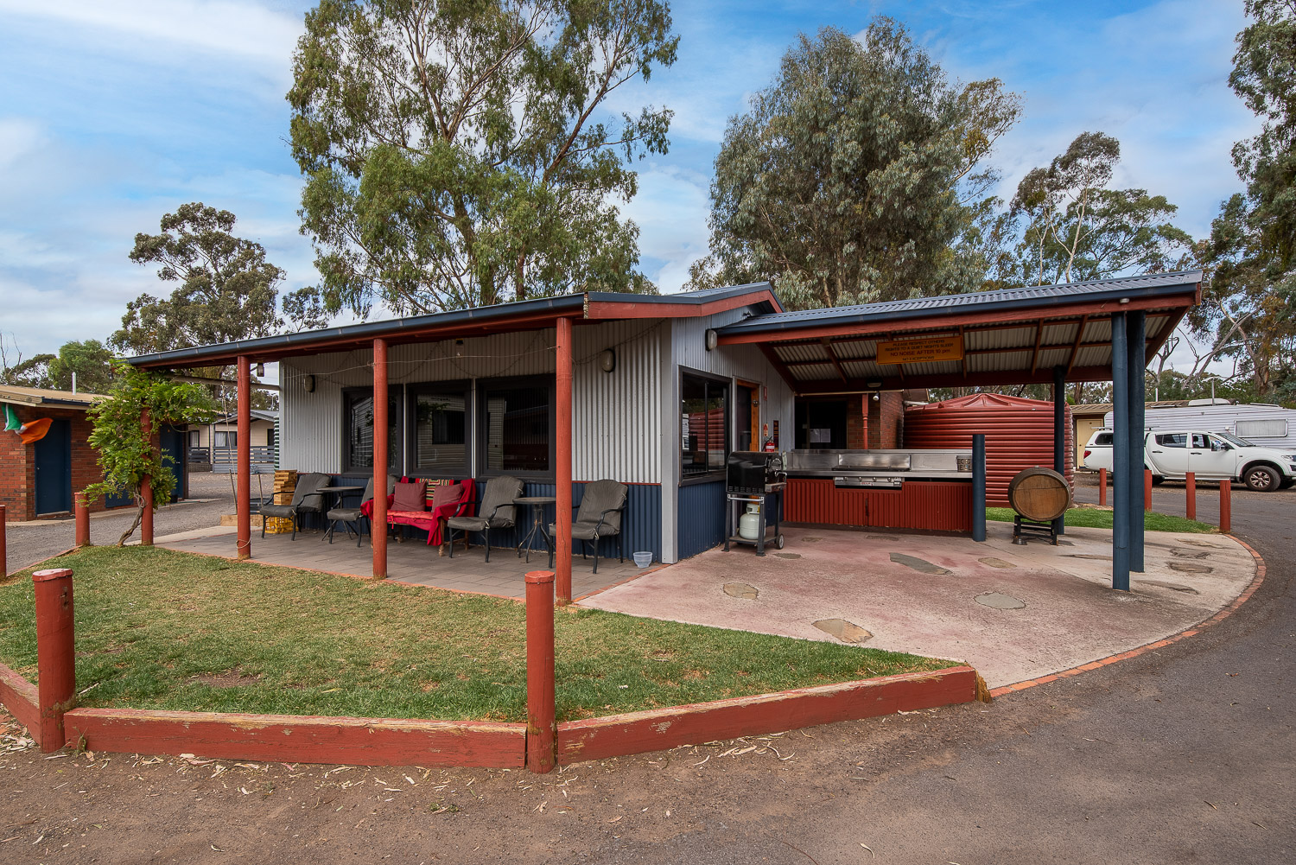
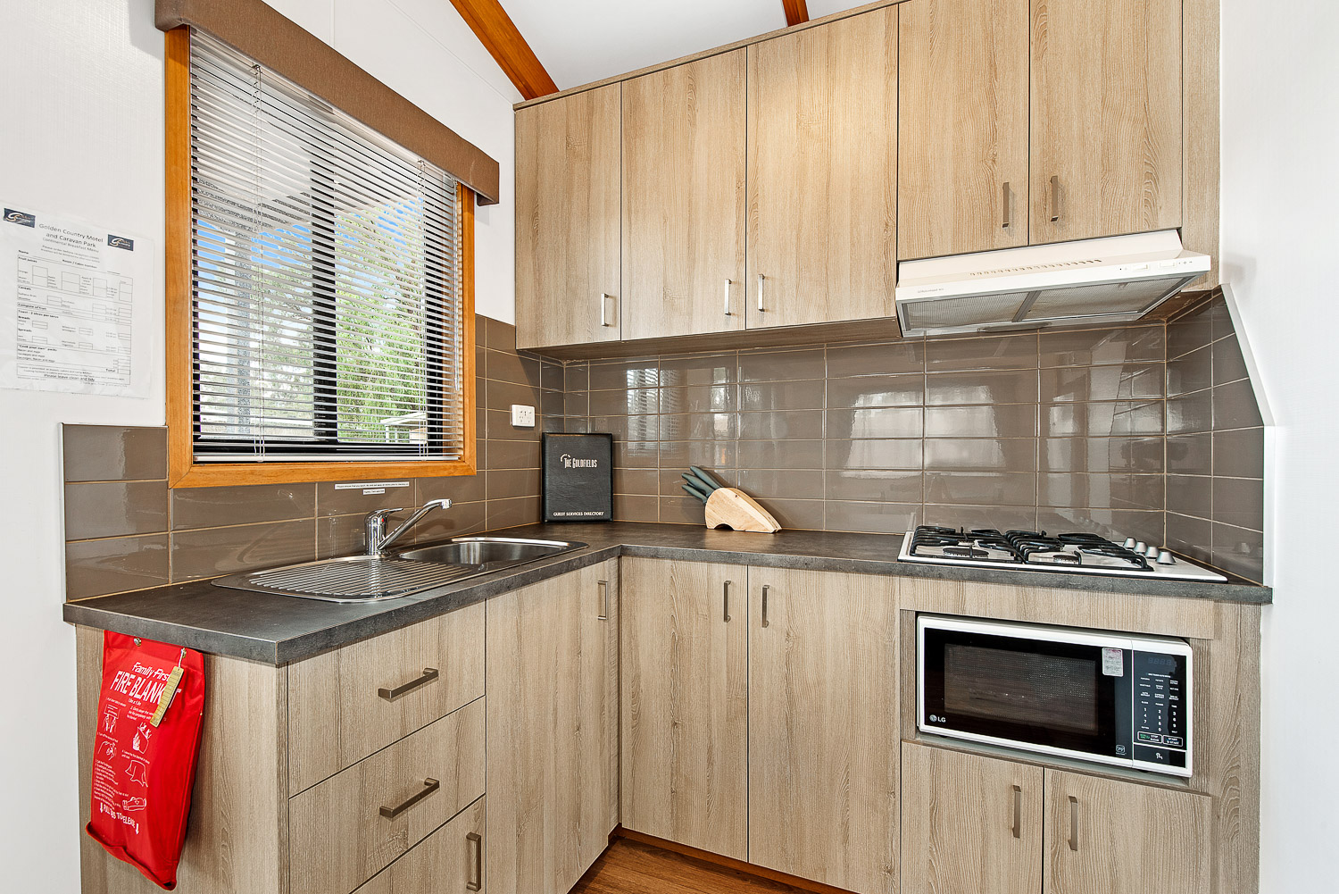

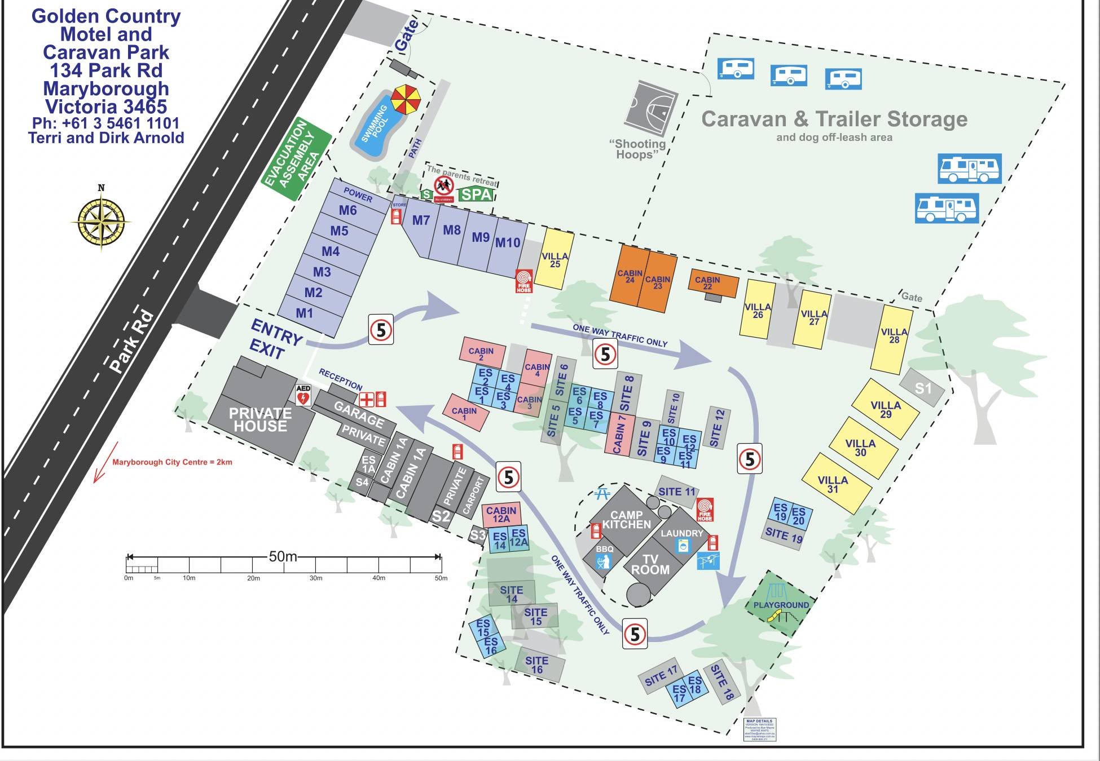

ACCOMMODATION AT MOTEL IS AS FOLLOWS:
10 MOTEL ROOMS [VARIOUS COMBINATIONS] 19 CABINS AND VILLAS
10 CARAVAN SITES ALL WITH ENSUITES
PRICES VARY ACCORDING TO CHOICE OF ACCOMMODATION AND ARE SUBJECT TO CHANGE
IF HQ IS FULL BY ANY CHANCE THERE ARE MORE MOTELS IN TOWN ONLY A SHORT DISTANCE AWAY AND ANOTHER CARAVAN PARK AROUND THE CORNER
NIGHT MEALS AT THE GOLF CLUB WHICH IS 50 METERS ACROSS THE ROAD
NOW FOR DAY-TO-DAY ACTIVITIES
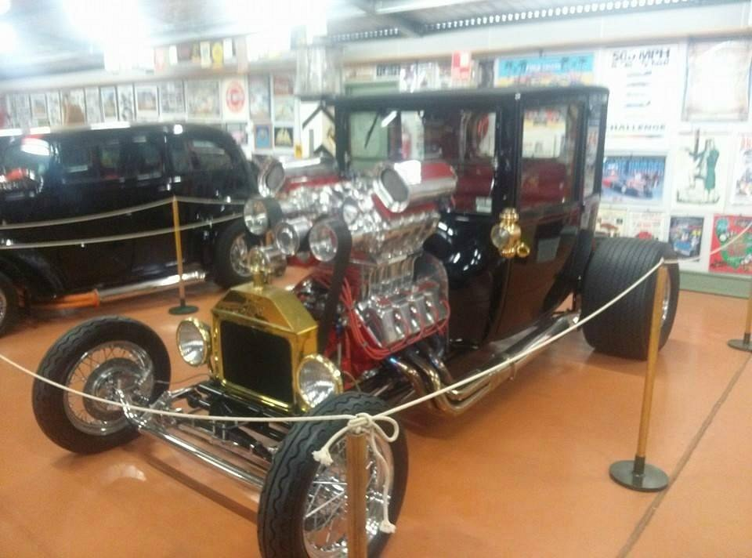
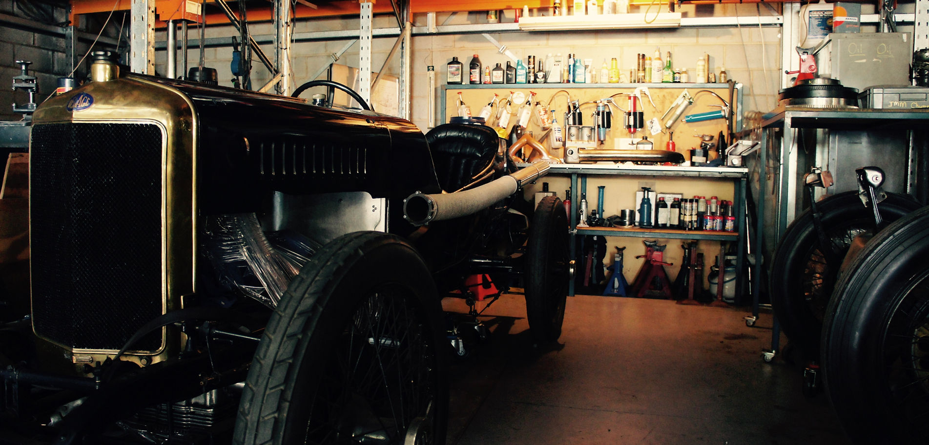
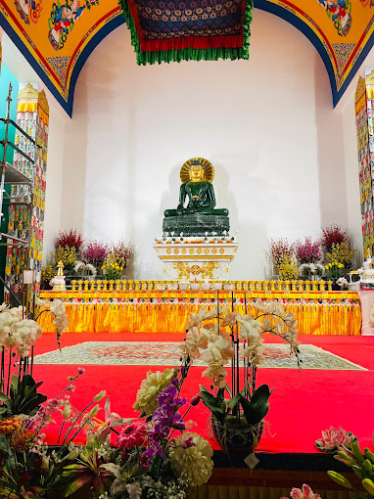

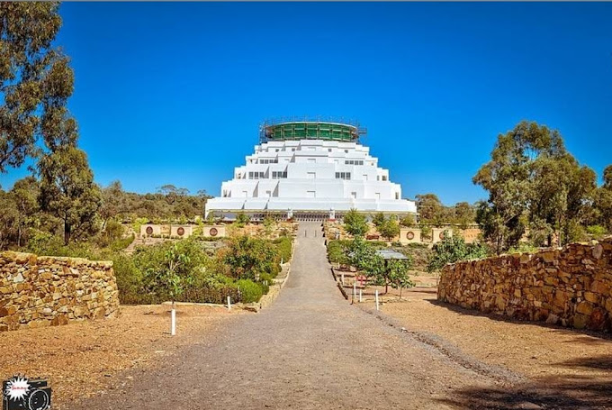
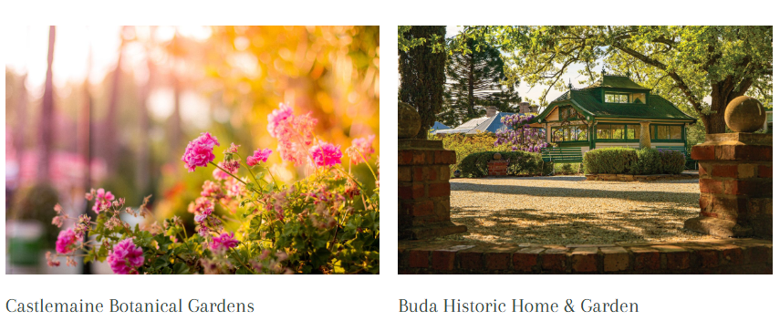
Other points of interest include Castlemaine and Maldon – (The Great Stupa of Universal Compassion) Please note they will hold all rooms and cabins only until the end of July. At this time half the remaining vacant bookings will be released to the public and the rest by November.

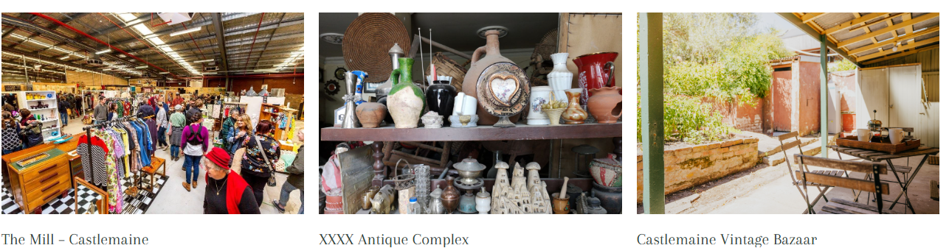

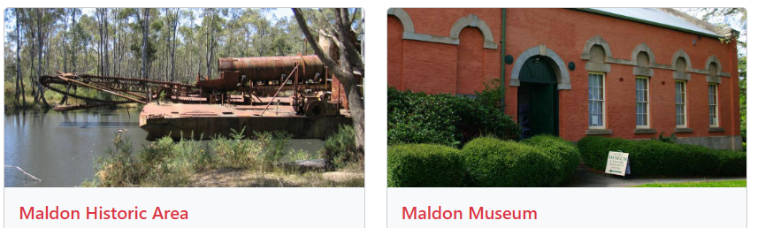

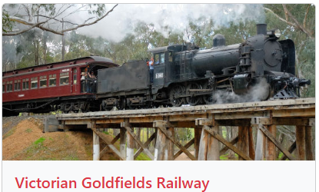

If questions, please contact:
Glenn Hubbard 0410 632 774 Geoff Trengove 0417 411 117 Glenn Bird 0427 533 902

